PROJECT REPORT OF CO-OP PROJECT AT INDUSTRY (MODULE-1)
ON
MoviFy
(MOVIE RECOMMENDATION SYSTEM)
submitted in partial fulfilment of the requirements for the award of degree of

BACHELOR OF ENGINEERING
In
COMPUTER SCIENCE AND ENGINEERING
Submitted by: Supervised By:
Parag Pratim Pan Dr. Gurpreet Singh
2210990635 Mentor
Chitkara University

DEPARTMENT OF COMPUTER SCIENCE AND ENGINEERING
CHITKARA UNIVERSITY
CHANDIGARH-PATIALA NATIONAL HIGHWAY, RAJPURA, PUNJAB, INDIA

CONTENTS

S.No. | Title | Page No.
 | Declaration | ii
 | Acknowledgement | iii
 | List of Figures and Tables | iv
 | Abstract
1 | Introduction | 1
2 | System Requirements
2 | Methodology
3 | Software Design (architecture/UML/DFD/UI-UX whichever is relevant to your project)
4 | Implementation Details (Frameworks, APIs/Core logic /code snippets/Database design and schema)
5 | Testing and Validation
6 | Major Findings/Outcomes/Output/Results
7 | Conclusion and Future Scope
 | References
 | Appendices

DECLARATION

We hereby declare that the project work titled, “Movie Recommendation System” submitted as part of Bachelor’s degree in CSE, at Chitkara University, Punjab, is an authentic record of our own work carried out under the supervision of Dr. Gurdeep Singh.

Signature(s):

Abstract

The exponential growth of digital entertainment has made intelligent recommendation systems essential for platforms such as Netflix, Amazon Prime, and YouTube. Users often struggle to select movies due to the massive volume of content. To address this challenge, MoviFy, an AI and Machine Learning–powered movie recommendation system, is developed using a content-based filtering approach.

The system employs TF-IDF Vectorization and Cosine Similarity to compute similarity between movies based on their metadata such as genre, cast, keywords, and plot descriptions. The web interface is implemented using Flask, while datasets are processed using Pandas, NumPy, and Scikit-Learn. Additional data such as ratings, posters, and summaries are fetched using OMDb API and YouTube API.

A local AI chatbot powered by DeepSeek R1 via Ollama is integrated to enhance user interaction and provide detailed queries about movies, actors, and related information not present in the dataset.

The results indicate that MoviFy successfully provides relevant and accurate movie recommendations with an interactive and modern UI, making it suitable as a foundation for future industry-level intelligent recommendation systems.

ACKNOWLEDGEMENT

I would like to express my sincere gratitude to Dr. Gurdeep Singh, my project guide, for his valuable guidance and support throughout this project. I am thankful to our Head of Department and all faculty members for their encouragement.

I am also grateful to my friends and family for their constant motivation and help during the development of the Movie Recommendation System using AIML project.

Introduction

Background
Online movie consumption has expanded significantly, leading to a need for intelligent systems that recommend movies aligned with user preferences. Manual searching is inefficient due to the massive volume of available films. Recommendation systems solve this by analyzing user interests and suggesting similar movies.

Problem Statement
Users face difficulty choosing movies due to information overload. There is a necessity for a system that can intelligently recommend movies based on user search queries and movie attributes using machine learning techniques.

Objectives
- Develop a content-based movie recommendation system.
- Implement TF-IDF and Cosine Similarity.
- Build a modern web interface using Flask & HTML templates.
- Integrate OMDb API for additional metadata.
- Add a local AI chatbot using DeepSeek/Ollama.
- Provide accurate, user-friendly movie suggestions.

Scope
MoviFy is suitable for students, researchers, developers, and entertainment platforms looking for lightweight and accurate recommendation systems.

System Requirements

Hardware Requirements
- Processor: Intel i3 or above
- RAM: 4GB minimum (8GB recommended)
- Storage: 250GB+ recommended
- Optional: GPU for chatbot acceleration

Software Requirements
- Windows/Linux
- Python 3.x
- Flask
- Pandas, NumPy, Scikit-Learn
- OMDb API & YouTube API
- SQLite Database
- HTML/CSS/JavaScript
- Ollama (for local LLM chatbot)

Methodology

Data Collection
Dataset contains:
- Title
- Genre
- Keywords
- Cast
- Director
- Plot
- Poster
- Ratings

Data Preprocessing
- Remove missing values
- Lowercasing text
- Removing duplicates
- Combining metadata
- Tokenization

Feature Engineering
- Combine Genre + Keywords + Cast + Director
- Apply TF-IDF Vectorizer
- Convert text → numerical vectors

Similarity Computation
Using Cosine Similarity:
$$Similarity=\frac{A⋅B}{∣∣A∣∣⋅∣∣B∣∣}$$
Recommendation Algorithm
- User searches movie
- System finds its index
- Uses similarity matrix
- Returns top-10 similar movies

API Integration
OMDb API → Plot, Poster, Ratings
YouTube API → Official Trailers

AI Chatbot Integration
DeepSeek R1 (LLM) through Ollama fetches:
- Actor bios
- Plot explanations
- Movie trivia
- Inter-movie relationships

Software Design
System Architecture:

+--------------------+
Movie Dataset
+---------+---------+
|
v
+--------------------------+
Data Preprocessing
(Cleaning & Merging)
+-------------+------------+
|
v
+---------------------------+
Feature Extraction
(TF-IDF Vectorizer)
+-------------+-------------+
|
v
+-------------------------------+
Similarity Computation
(Cosine Matrix)
+---------------+---------------+
|
v
+-----------------------------------+
Recommendation Engine
(Top-N Similar Movies)
+------------------+-----------------+
|
v
+----------------------------------------+
Flask Backend API Endpoints
(/recommend, /details, /chat)
+-------------------+-------------------+
|
v
+-------------------------------------+
Frontend (HTML/CSS/JS)
Search Bar • Modal • Chatbot
+------------------+------------------+
|
v
+------------------------------------------+
External Services / APIs
- OMDb API (Movie Metadata)
- YouTube API (Trailers)
- Ollama (DeepSeek R1 Chatbot)
+---------------------+---------------------+

Implementation Details
Frontend Implementation
Includes:
- HTML templates
- CSS animations
- Dynamic rows
- Poster background grid
- Search bar suggestions
- Modal popups

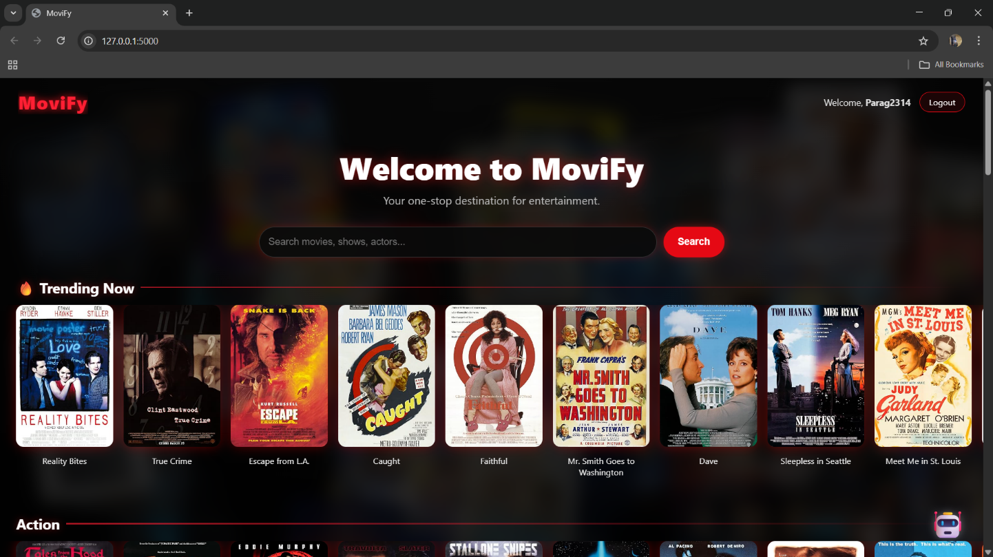
MoviFy Homepage

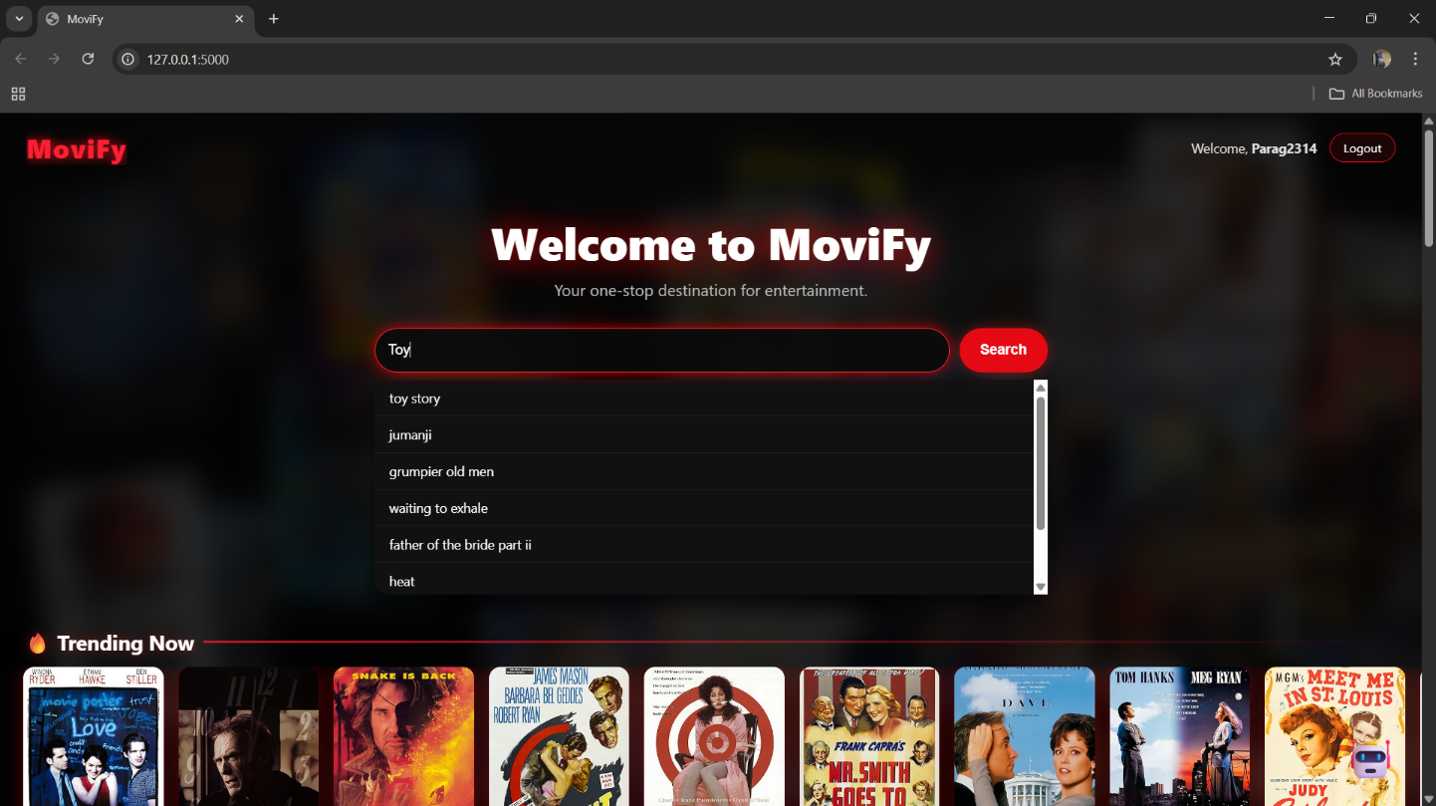
Search Bar + Autocomplete Suggestions

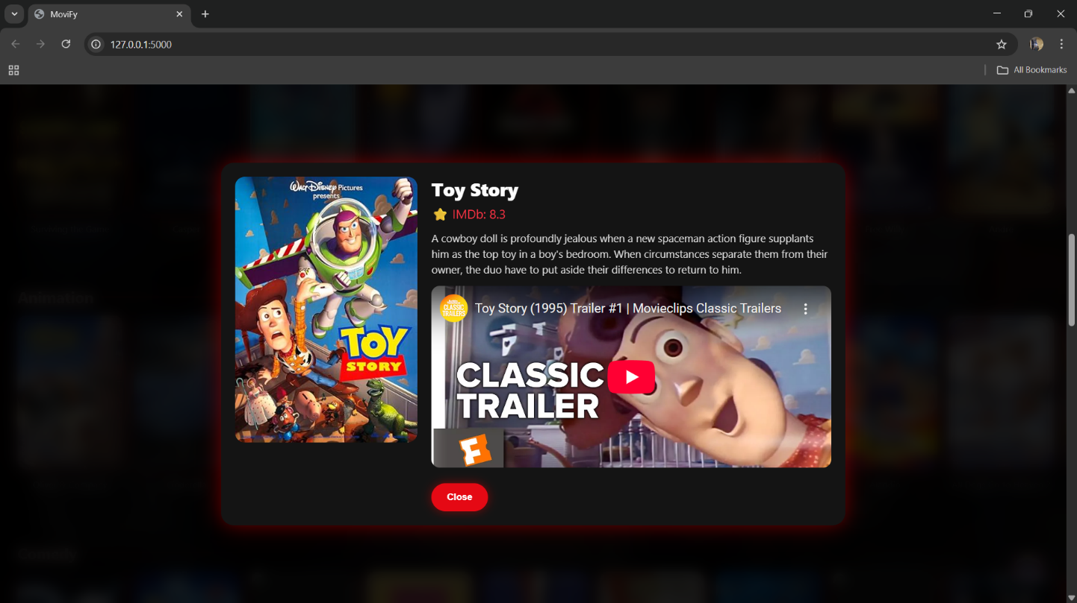
Movie Details Modal (Poster + Plot + Trailer)

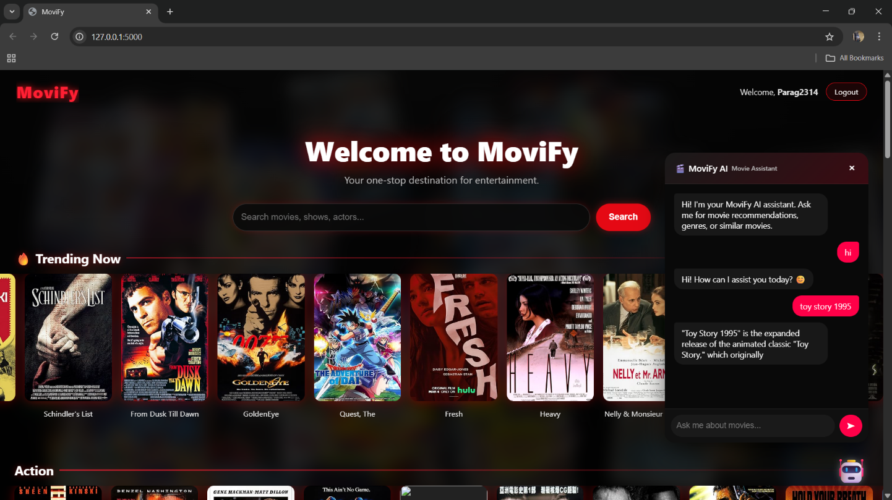
Chatbot

Backend Implementation (Flask)
Routes implemented:
- / — homepage
- /recommend — recommendation endpoint
- /movie_details/<title> — fetch movie info
- /autocomplete — search suggestions
- /chatbot — chatbot handler

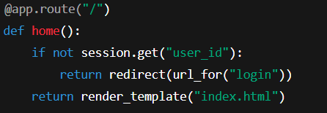
Home Page Route (/)
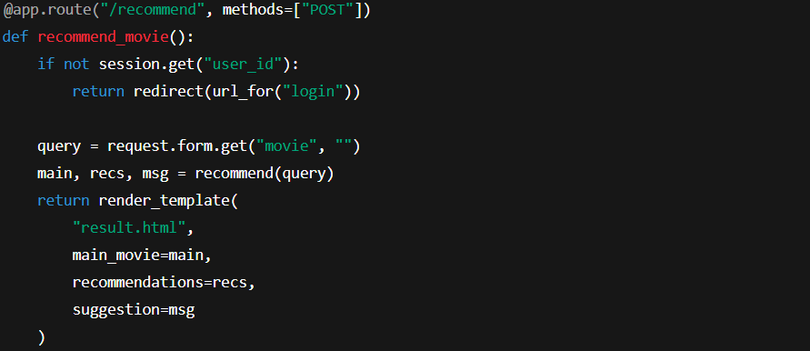
Recommendation Endpoint (/recommend)

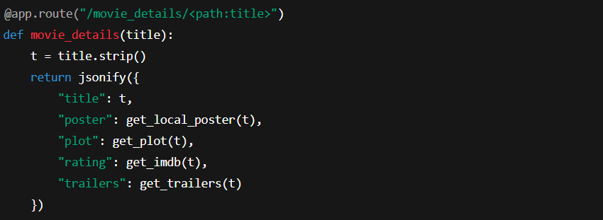
Movie Details API (/movie_details/<title>)

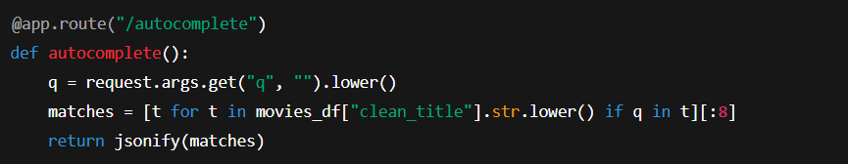
Autocomplete Route (/autocomplete)

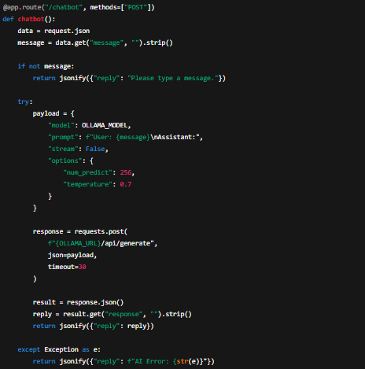
Chatbot Handler (/chatbot)

Testing and Validation

Test Case 1: Movie Recommendation Function
- Feature Tested: Recommendation Engine
- Input: Toy Story
- Expected Output:
System should return a list of movies similar to Toy Story, based on genre, themes, and metadata.
- Validation Performed:
✔ Cross-checked recommendations manually
✔ Verified similarity in genre (Animation, Family, Adventure)
✔ Verified thematic resemblance (friendship, humour, child-friendly storytelling)
- Result:
Recommendations matched expected genre/theme patterns.

Test Case 2: Autocomplete Search Bar
- Feature Tested: Autocomplete Suggestions
- Input: Typing "To"
- Expected Output:
System should show top matching movie titles such as Toy Story, etc.
- Validation Method:
✔ Checked suggestions appear in <100ms
✔ Verified accuracy of suggested titles
- Result:
Autocomplete worked smoothly and returned correct matches.

Test Case 3: Movie Details Modal Popup
- Feature Tested: Movie Details Modal
- Input: Clicking on a movie card
- Expected Output:
Display:
  - Poster
  - IMDb Rating
  - Short Plot
  - Trailer (YouTube embed)
- Validation:
✔ Compared displayed IMDb ratings with OMDb
✔ Verified plot accuracy
✔ Embedded trailer loads correctly
- Result:
Modal displays all details accurately.

Test Case 4: Homepage Genre Rows
- Feature Tested: Dynamic Genre Rows
- Expected:
Movies categorized into genres (Action, Comedy, Drama, etc.)
- Validation:
✔ Checked each row loads posters
✔ Confirmed movies belong to displayed genre
- Result:
Genres and trending movies load correctly from cached data.

Test Case 5: Chatbot Functionality
- Feature Tested: AI Chatbot (DeepSeek R1 via Ollama)
- Input Examples:
  - “Recommend some thriller movies.”
  - “What is the plot of Avatar?”
- Expected Output:
System should respond with meaningful movie information.
- Validation:
✔ AI responses matched dataset & external movie info
✔ No errors or delays during response generation
✔ Chatbot able to provide info not present in CSV
- Result:
Chatbot works accurately and consistently.

RESULTS & DISCUSSION

MoviFy produced accurate recommendations such as:
- Searching Inception → recommends Interstellar, Shutter Island, The Prestige
- Searching Avengers → recommends Iron Man, Thor, Captain America

UI results:
- Fast load times
- Modern UI/UX
- Successful chatbot integration

Conclusion and Future Scope

Conclusion:
MoviFy successfully demonstrates an AI-based content recommendation system with integrated chatbot support. It uses machine learning, natural language processing, and web technologies to deliver accurate movie suggestions and a highly interactive interface.

Future Scope:
- Add collaborative filtering
- Implement TMDb API
- Deploy on cloud
- Add watchlist/personalized profiles
- Add trending/real-time analytics

References

- MovieLens Dataset – https://grouplens.org/datasets/movielens
- Scikit-learn Documentation – https://scikit-learn.org
- Flask Framework – https://flask.palletsprojects.com
- Python Official Docs – https://www.python.org/doc/

